

***QURE*** *Help… a few clicks away*



***Guided by:***

***A Saravana Kumar***

***Developed by:***

***Amulya Meka, Athul KS,***

***Arjun, Ragni Garg,***

***Aaruni Aggarwal ,***

***Alok Kumar, Gayatri Sama***



**Table of contents**

### Abstract

1. *Product Description-*
   1. *Modules*
   2. *Team Profile*
   3. *Assumptions and Constraints*
   4. *Project Deliverables*
2. *High Level Diagrams*
   1. *Use-Case Diagram*
3. *Low Level Diagrams*
   1. *Class Diagram*
4. *Modular Description*
5. *Work Flow*
6. *Database Diagram*
7. *References*



**1 ABSTRACT**

The objective of the project is to provide essential medical services online to users irrespective of their location. People needing medical services often need to travel long distances. Even in urban areas the service is sometimes not available immediately. Patients and doctors hardly communicate with each other. And also patients had to wait for long time in order to communicate with the doctor. The motivation to build the system is that very few or no doctors are available at remote locations, limited hour services and lack of sophisticated medical equipment and no patient’s history or lab data management. Through our proposed system, users can connect through their home internet or approach any nearby place to get these services.



# PRODUCT DESCRIPTION

## MODULES

* + - *Registration – Doctor and Patient*
    - *Login - Doctor and Patient*
    - *Patient - Search Doctors*
    - *Patient - Book Appointments*
    - *Doctor – View Appointments*
    - *Chat with doctor*
    - *Rating doctor*
    - *Health Blogs*
    - *Logout*
  1. **KEY ROLES**

|  |  |  |
| --- | --- | --- |
| **Name** | **Role** | **Email ID** |
| Athul KS | GUI, Business  logic & DB | [athulks1](mailto:athulks1)[@in.ibm.com](mailto:reshma.s@brillio.com) |
| Amulya Meka | GUI, DB &  Business Logic | [amulm](mailto:pooja.chandran@brillio.com)ek1[@in.ibm.com](mailto:reshma.s@brillio.com) |
| Aaruni Aggarwal | Business Logic & DB | [aaragga1@in.ibm.com](mailto:aaragga1@in.ibm.com) |
| Ragni Garg | Business Logic, DB | [ragni12@in.ibm.com](mailto:ragni12@in.ibm.com) |
| Alok Kumar | Business Logic, GUI & DB | aloku111[@in.ibm.com](mailto:reshma.s@brillio.com) |
| Arjun | GUI | [arjunm](mailto:roshini.raj@brillio.com)12[@in.ibm.com](mailto:reshma.s@brillio.com) |



* 1. ***Assumptions and Constraints***
     1. *Assumptions: N/A*
     2. *Constraints:*

***Hardware Constraints***

* + - * *System Type 64 bit*
      * *RAM 8 GB*

***Software Constraints***

* + - * *Operating System Windows 10*
      * *Programming Language JAVA, TypeScript*
      * *Architecture MVC*
      * *Environment JRE 8*
      * *Platform JDK 1.8*
      * *IDE Spring Tool Suite 3*
      * *Database MongoDB 4.2*
      * *Server Apache Tomcat 9*



## Project Deliverables Deliverables include:

### Software Project Proposal.

* *Project Plan*
* *Project Proposal*
* *Technical Design Document*
* *Projects build along with required jars in war format.*



*3* **HIGH LEVEL DIAGRAMS**

***3.1 Use-Case Diagram***

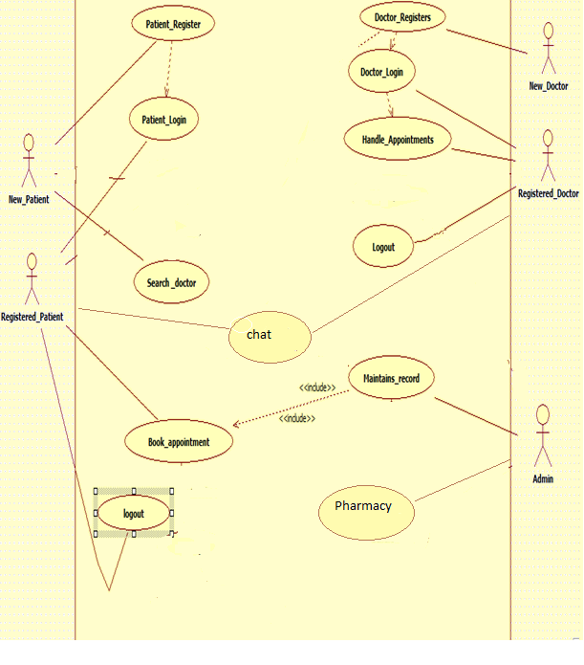



1. **LOW-LEVEL DIAGRAMS**

#### CLASS DIAGRAM



1. **MODULAR DESCRIPTION**
   1. ***Login Module****:*

*Enables the registered user or the registered doctor to enter the web application.*

* + 1. ***Registered User Login - Patient:*** *The already registered user enters his credentials and logs in to his profile to search a nearby hospital and also to book an appointment in the same.*
    2. ***Registered User Login – Doctor:*** *The already registered doctor enters his credentials in the doctor login page and enters his profile to view his appointments.*

***5.1.1 Registered User Forgot Password – Patient and Doctor:*** *In case the user forgets his password, he enters into this page to answer a security question and retrieve his password.*

#### New User Registration Module:

*Here the new user-patient or doctor fills in a registration form with his personal details and signs up into the website. Immediately followed by a username and password generation. The user is required to change his password and login.*

* 1. ***Search Module-Patient:(Location)***

*Here the patient enters the required location and a list of doctors in that locality is displayed. From which the patient clicks on the required one.*



* 1. ***Search Module-Patient:(Specialization)***

*Here the patient enters the required specialization and a list of doctors in that locality is displayed. From which the patient clicks on the required one.*

* 1. ***Appointment module:***

*The list of the available doctors is displayed from which he can choose the required and book an appointment. After which a confirmation message is displayed on the page.*

* 1. ***Book Medicine module:***

*The patients can order the medicines prescribed by the doctor through QURE pharmacy which is maintained by the admin.*

* 1. ***Doctor module:***

*The doctor enters his profile and is able to view the number of appointments he has got for that day.*

* 1. ***Health Blogs:***

*Common health concerns and the related feasible articles are displayed in this page.*

* 1. ***Chat:***

*Patients can chat with the doctor to clarify their health issues online.*

* 1. ***Rating the doctor:***

*The patient can rate the doctor after the appointment has been completed.*

* 1. ***FAQ:***

*Frequently asked questions about the website.*

**6. WORK FLOW**

* 1. **Home Page:**





* 1. ***Health Blogs:***



* 1. **Doctor Registration:**

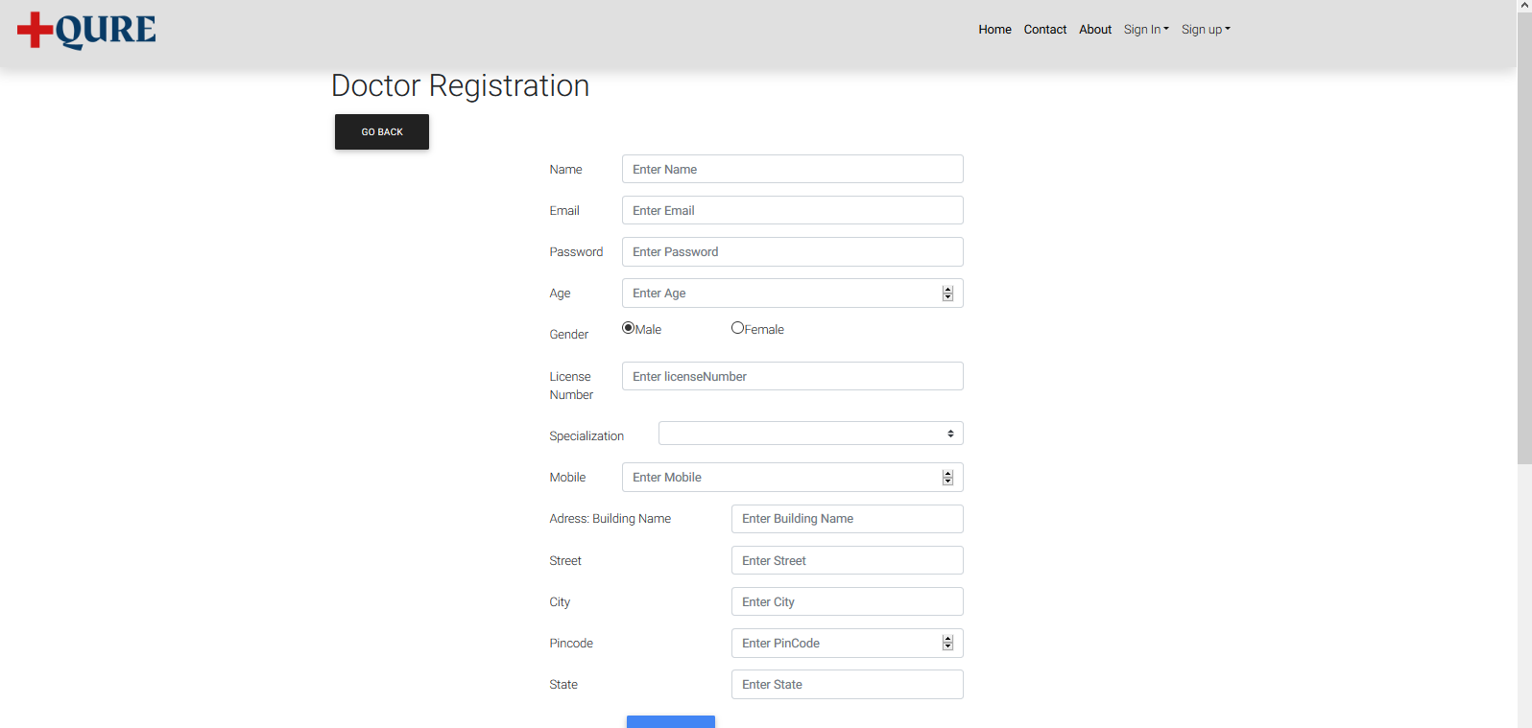



* 1. ***Patient Registration:***

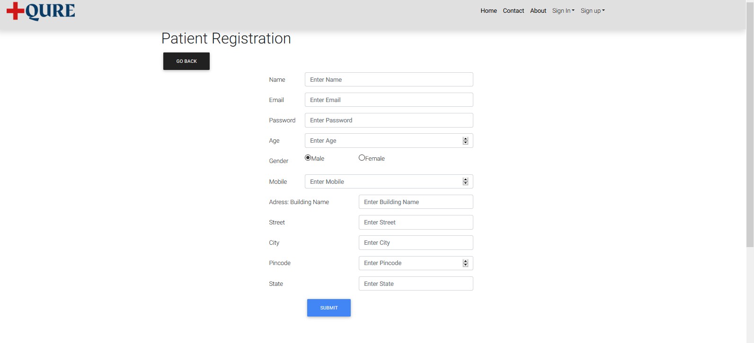



* + 1. ***Forgot Password-Doctor:***

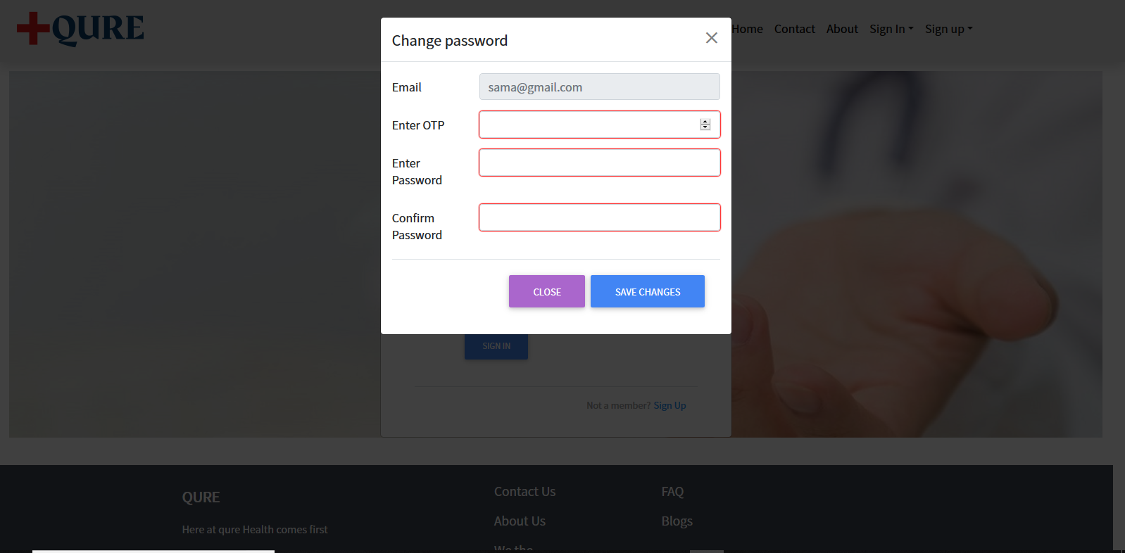

* + 1. ***Forgot Password-Patient:***

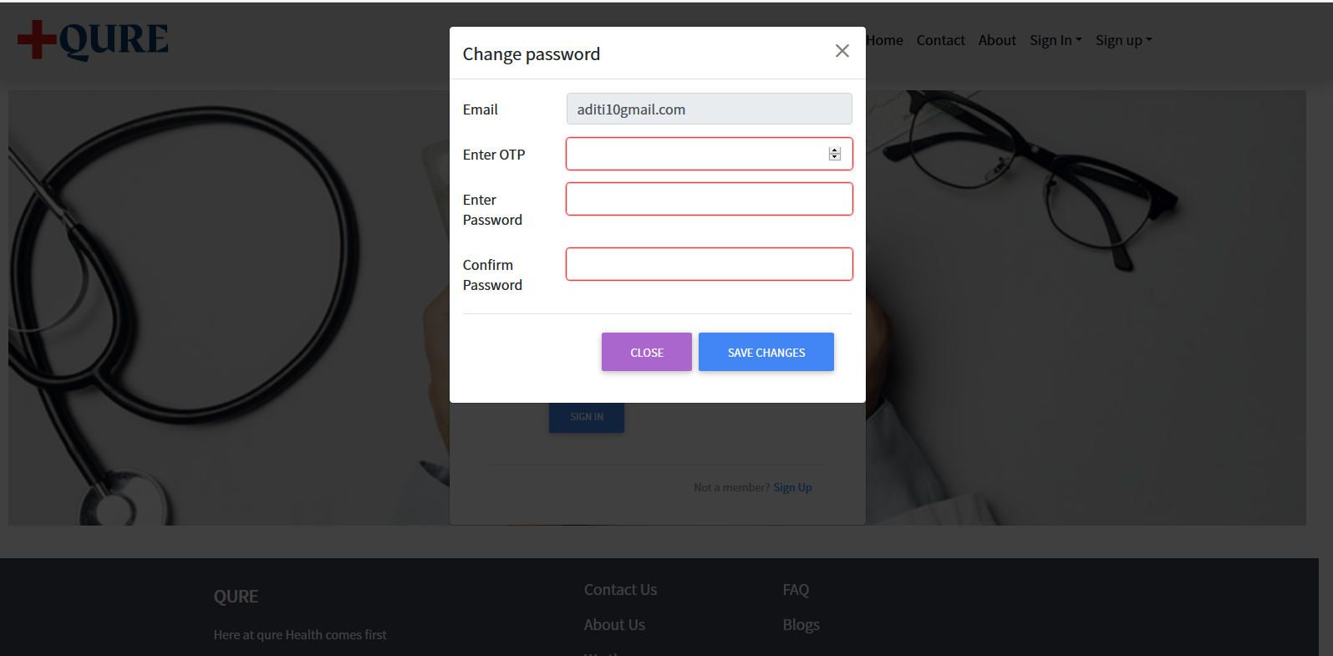

* 1. ***Login Page - Doctor:***

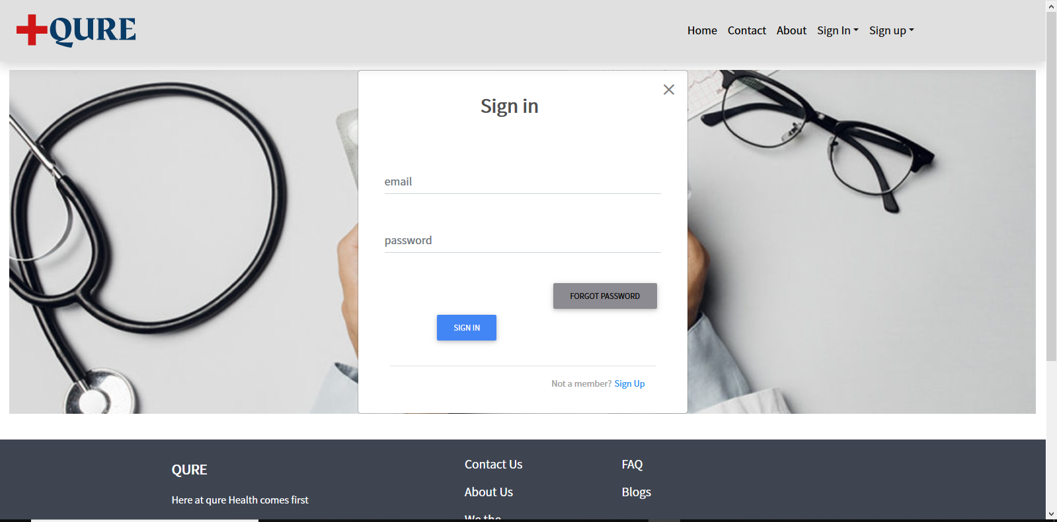

* 1. ***Login Page– Patient:***

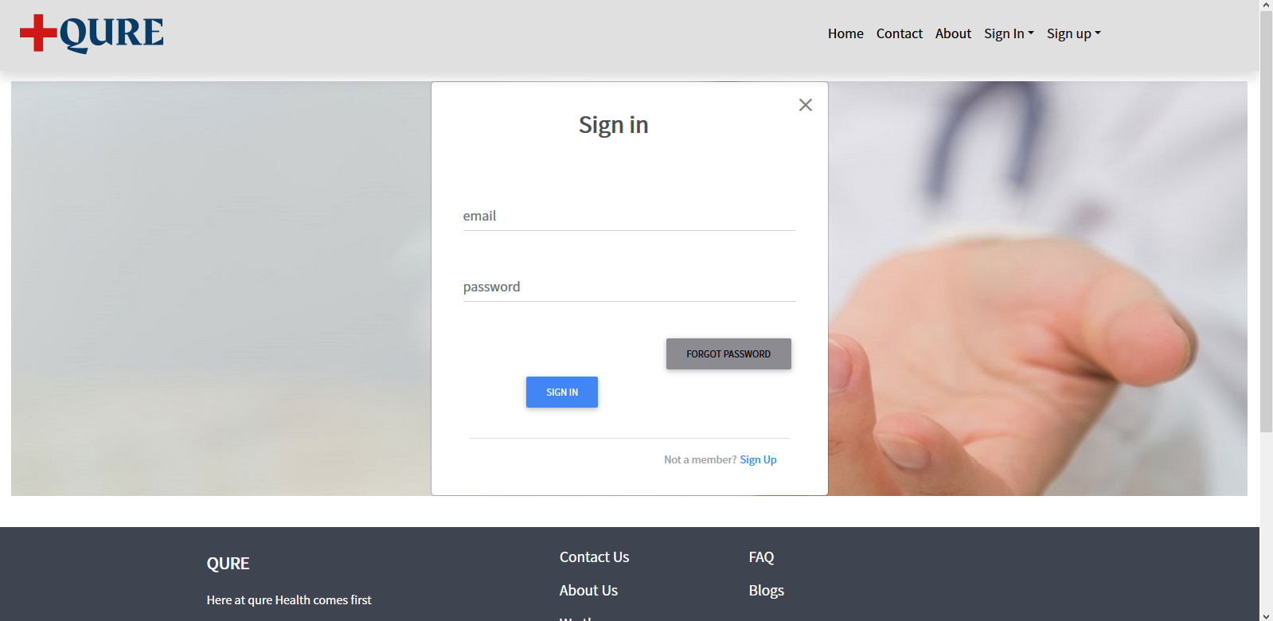

* 1. ***Patient’s Landing page:***

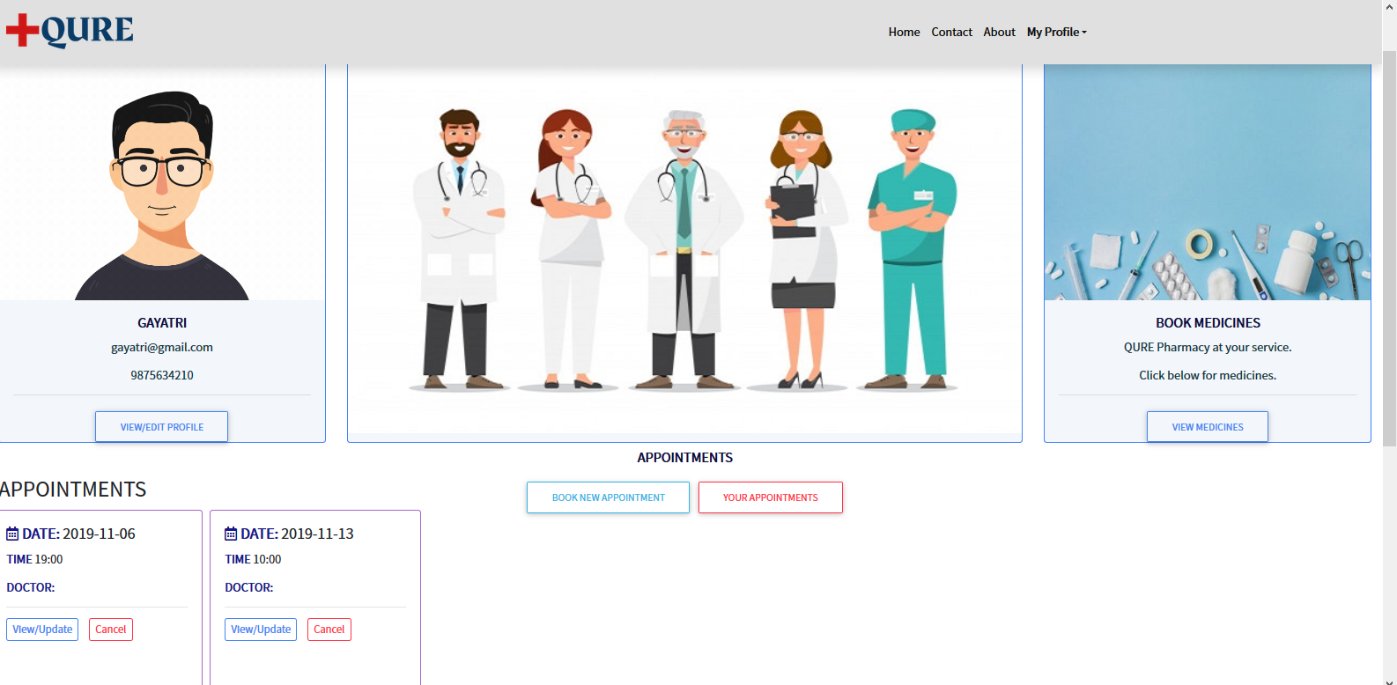



* 1. ***Search by Location and Specialization:***

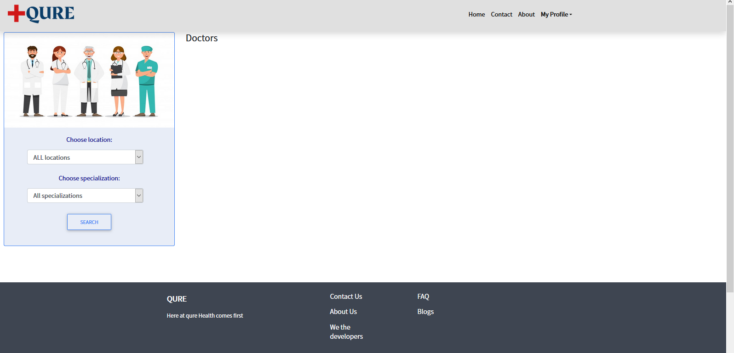



* 1. ***Appointment booking:***

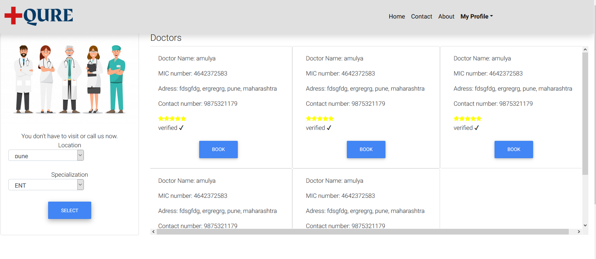



* 1. ***Booked Appointments-Doctor:***

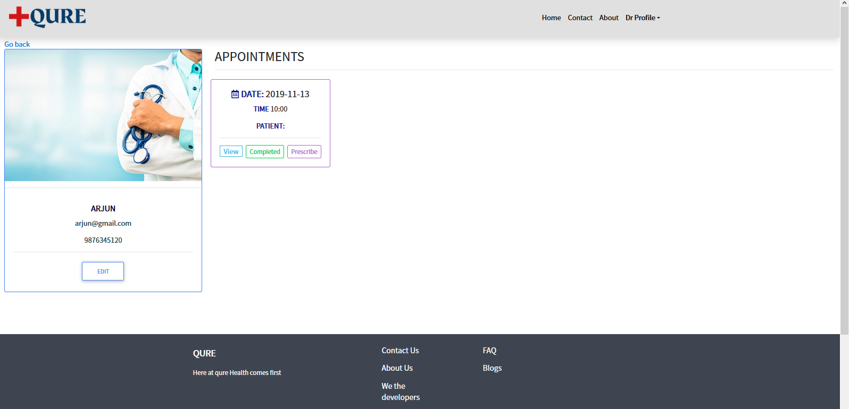

* 1. **Chat**

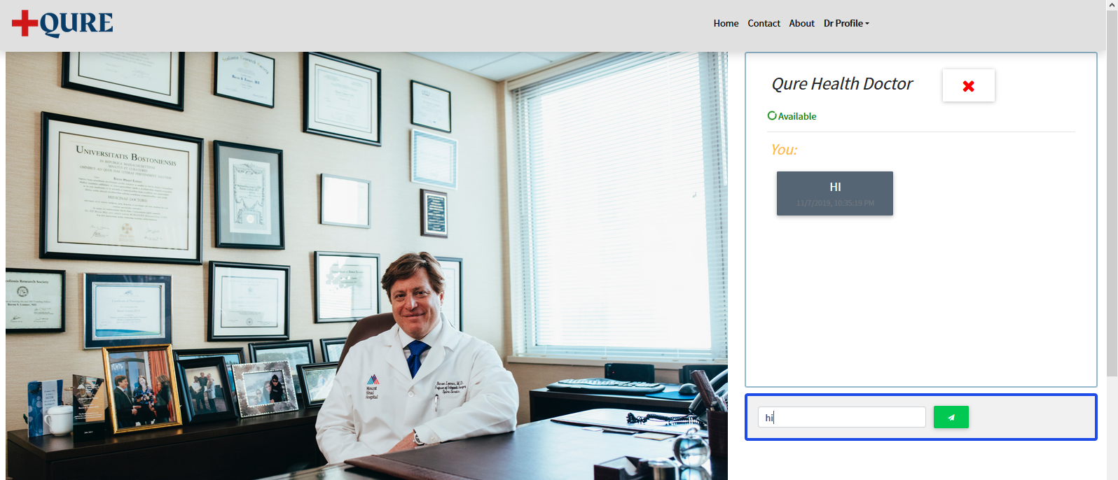

* 1. ***Admin login:***

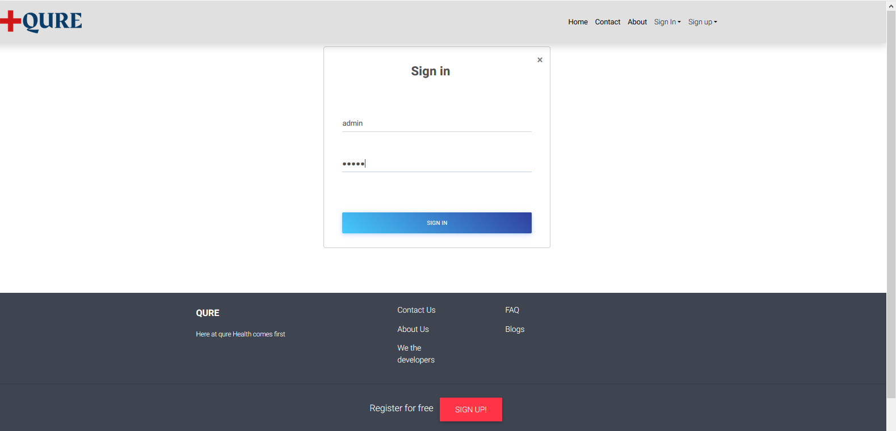

* 1. ***Admin landing page:***

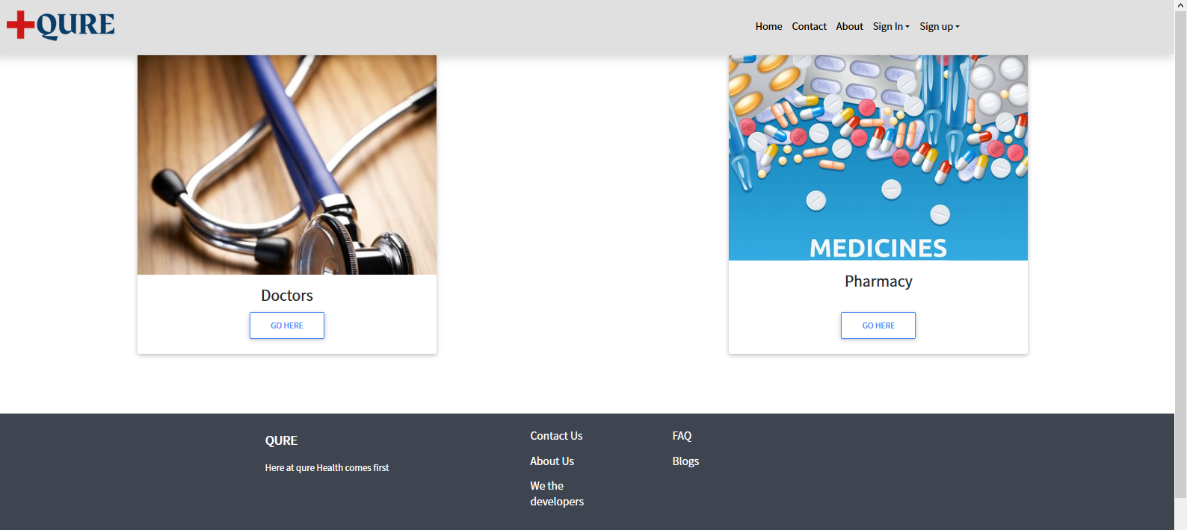



* 1. ***Doctors List***

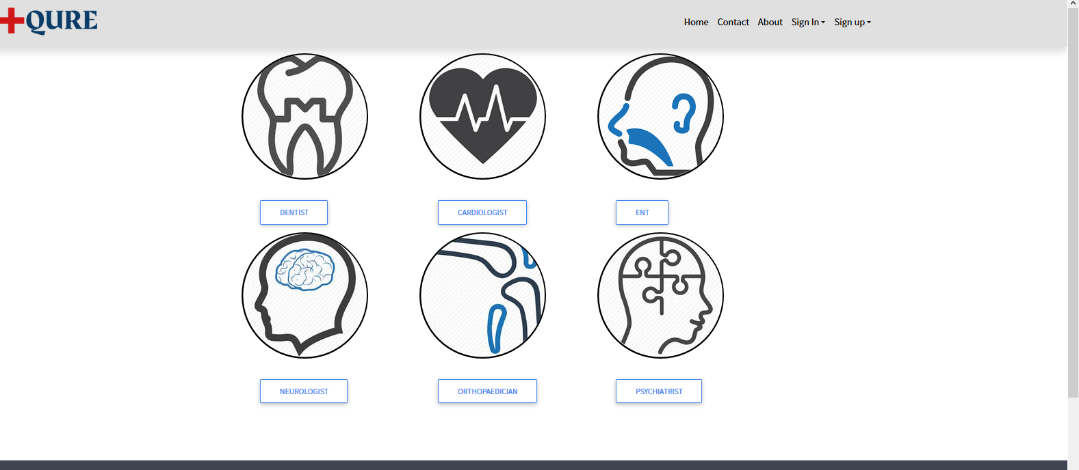

* 1. **Pharmacy**

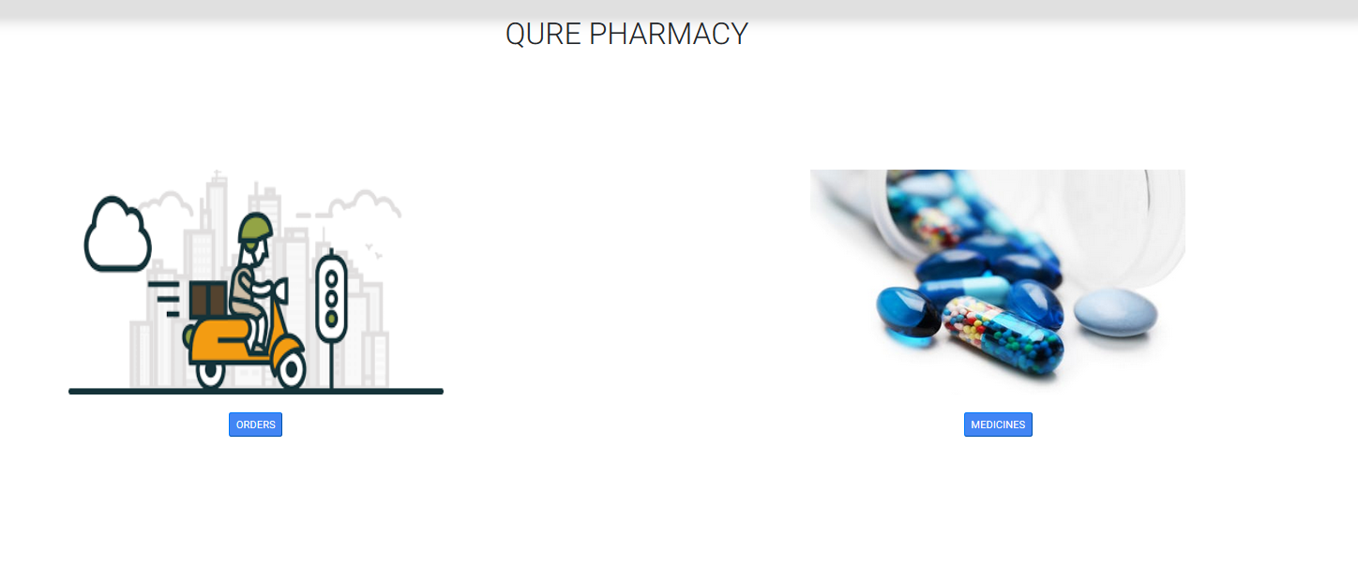



* 1. **FAQ**

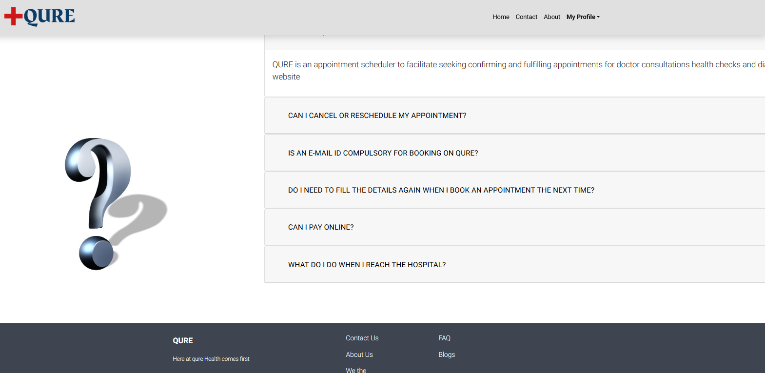

***About Us:***

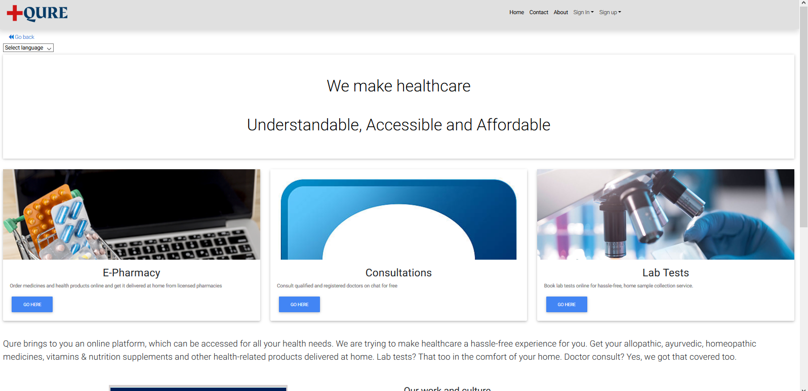



* 1. ***Contact Us:***

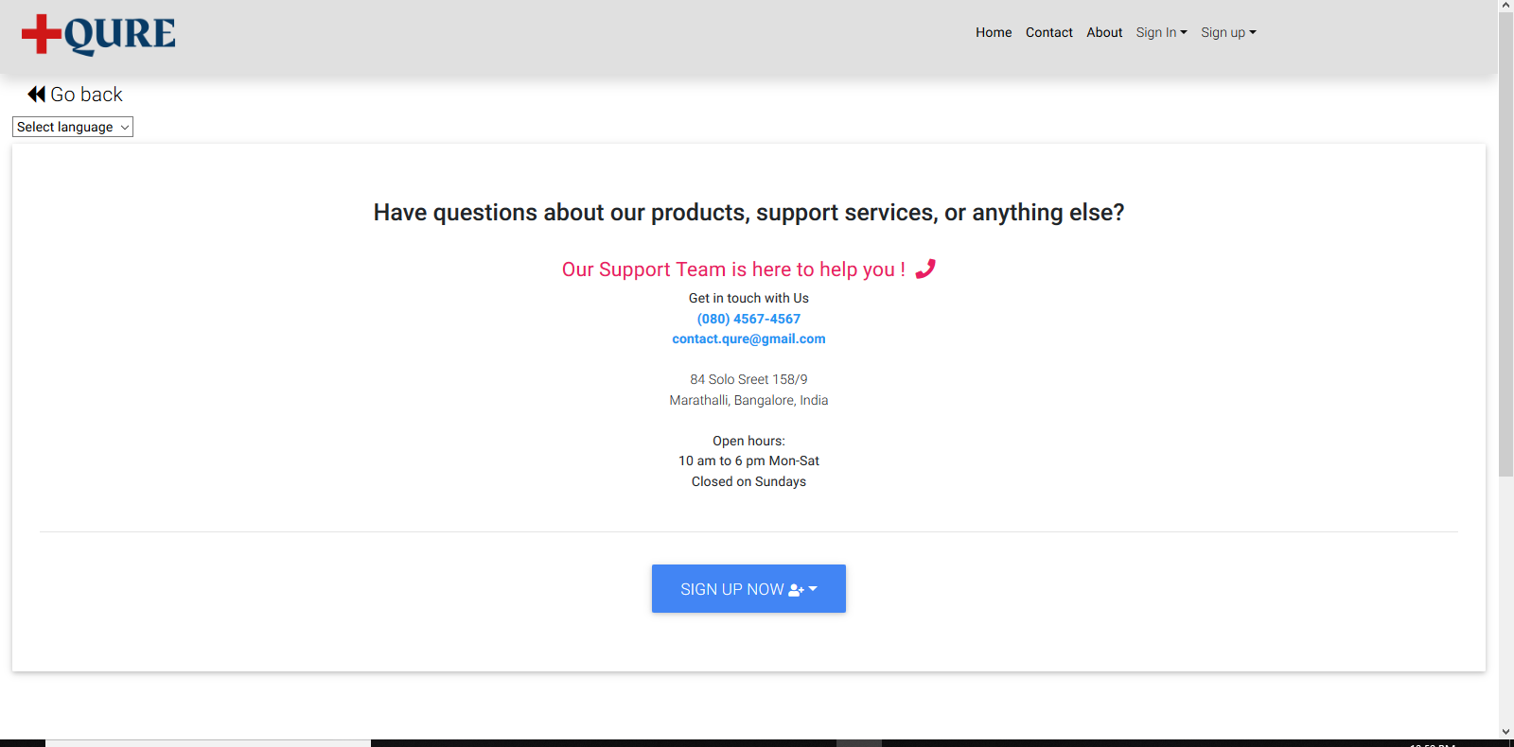



**8. REFRENCES:**

[1]. Wikipedia, [http://en.wikipedia.org](http://en.wikipedia.org/)

[2]. Java The Complete Reference by Herbert Schild